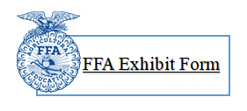

Name: ________________________ Class No.:___________ Project: ______________________
County: _____________________ FFA Chapter: _______________ Grade completed: ______

What was your exhibit goal(s)? (What did you plan to learn or do?)

_____________________________________________________________________________________
_______________________________________________________________________________________________________________________________________________________________________________________________________________________________________________________________
_____________________________________________________________________________________

What steps did you take to learn or do this? (Explain what you did so it is easily understood. The judge wants to know & understand the steps you used to make your exhibit)

_____________________________________________________________________________________
_______________________________________________________________________________________________________________________________________________________________________________________________________________________________________________________________
_____________________________________________________________________________________

What were the most important things you learned?

_____________________________________________________________________________________
_______________________________________________________________________________________________________________________________________________________________________________________________________________________________________________________________
_____________________________________________________________________________________
_____________________________________________________________________________________
______________________________________________________________________________________________________________________________________________________________________

Ribbon Received: _________

