EXHIBITING FLOWERS

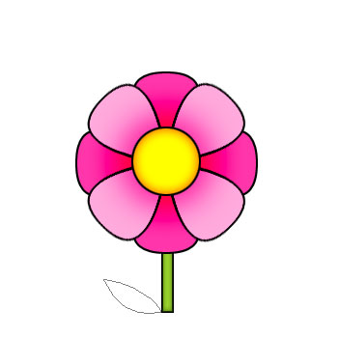

*Flowers exhibited must be grown by the 4-Her.
*Exhibit your flowers in a clear glass container. Save clear bottles throughout the year for the fair.
*There should be no foliage in the water when exhibiting a flower.
*Attach an exhibit tag to each glass container. It is important to write the kind and variety of plant exhibited on the exhibit tag.
*There is a maximum of 12 flowers to exhibit.
*Bring only one specimen of flower no matter what color or variety. If you have a single and a double variety of a flower you may bring both.
*The name, variety, uniformity, size and how clean the specimen is are all things that will be judged.
* Multiple blooms don’t have to be the same color.

