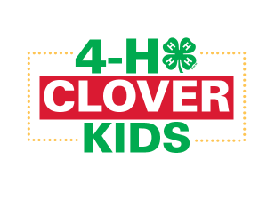
Second Tuesday of the Month | 3:00-4:30 pm |Fairview School | K-3rd graders
What Is Clover Kids?
Clover Kids is a FUN youth program specially designed for children in Kindergarten- 3rd grade. Clover Kids participate in activities, games, and other positive experiences in a supportive, creative, challenging and fun environment.

What Can Your Child Expect To Do In Clover Kids?
Participate in hands-on activities uniquely suited to their development *Have Fun* Grow and learn in a non-competitive environment* Develop lifelong skills* Meet new friends
Dates:
October 11th, November 8th, December 13th, January 10th, February 14th, March 21st, and April 11th

Contact Information: Poweshiek County Extension Phone: 641-623-5188 Email: xpoweshiek@iastate.edu

Registration:
Send the below form and payment to Poweshiek County Extension:
P.O. Box 70, Montezuma, IA 50171 or scan and email to xpoweshiek@iastate.edu
Registrations accepted on a first come – first served basis until Clover Kids is full (15-20 kids)
4-H Clover Kids Registration
Youth Name: ________________________________________________________________________
Grade: ____________ Age: __________ School: __________________________________________________________
Address: _______________________________________________ City, State, and Zip: ________________________
Parent Name: ________________________________ Parent Phone Number: ________________________________
Email: ____________________________________________________________________________________________
Name & phone number of an individual that could be contacted during Clover Kids (3:00 to 4:30 pm):

Permission to take photographs and record video/audio of youth during programming activities.
In addition, photographs and recorded video/audio may be electronically displayed. Yes _____ No _____
Child’s T-Shirt Size ________ Food/Other Allergies: ______________________________________________________

I would be willing to be a volunteer and help with the Clover Kids program: Yes _____ No _____

$40 enclosed (to cover t-shirts, snacks, and supplies): ______ (Please make checks payable to Poweshiek County Extension)
** If financial assistance is needed, an application is available for full and/or partial scholarships upon request.
Once we receive your Registration form, we will email you instructions on how to finish enrollment on 4-H online.
This institution is an equal opportunity provider. For the full nondiscrimination statement or accommodation inquires, go to www.extension.iastate.edu/diversity/ext

