What Should My write-up look like?

Cover Page
  - Title of Project
  - Photo of project
  - Name
  - Club

Goals
  - List at least 3 goals you have for the project
  - Goals should be attainable and specific – 3 parts HOW, WHAT, WHEN

Materials
  - List of materials used including price/cost of each item
  - Total cost of materials

Instructions
  - Step by step instructions on how you accomplished the project. Include photos to help better illustrate your steps. The judge should be able to construct the project based on your instructions that you have given

What you Learned
  - State what you learned from your project experience – new skills you gained, whether you enjoyed the project, and future goals for the project area

Elements & Principles of Design
  - Must include at least 3 different elements and principles of design to advance to State Fair
  - Handout on specifics elements of design

Decoupage Wood Letter “Y”

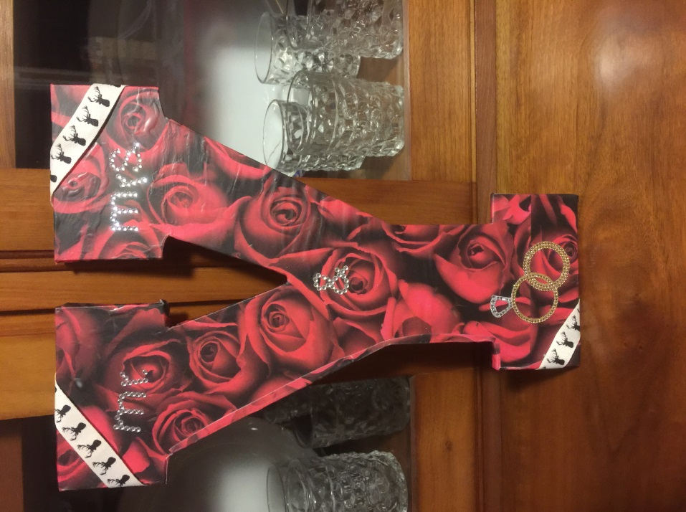

By: Kate Moore

4-H Club Name

Goals:
- I wanted to create a unique and personalized prop to use during wedding engagement photos, with my fiancé Josh.
- I wanted the prop to tie together both of our personalities and interests.
- I wanted to learn how to decoupage an unfinished piece of wood into a final project within a $10 budget

Materials
Quantity | Item | Cost
1 | 13 ½” Wood Unfinished Letter Y | $2.44
1 | 12” x 12” Scrapbook Page | $0.59
1 | Ring Embellishment | $1.99
1 | Mr. & Mrs. Embellishment | $1.99
1 | Roll Deer Antler Ribbon | $0.50
1 | Container Modge Podge | Already Had
1 | Small Paint Brush | Already Had
1 | Sharp Scissors | Already Had
1 | Plastic Tablecloth | Already Had
Tax |  | $0.53
Total Cost |  | $8.04

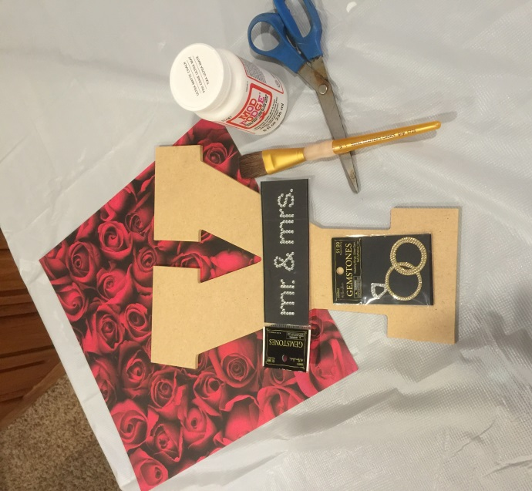

Instructions:
- I started off with the idea of using a prop from looking at different engagement photos that my photographer has taken. She uses a lot of props, and I wanted to be able to have a unique and personalized prop to use during my engagement photo session. I went to Hobby Lobby and purchased the supplies. The wood letter “Y” was on sale for 30% off, allowing me to purchase an additional embellishment for the project.

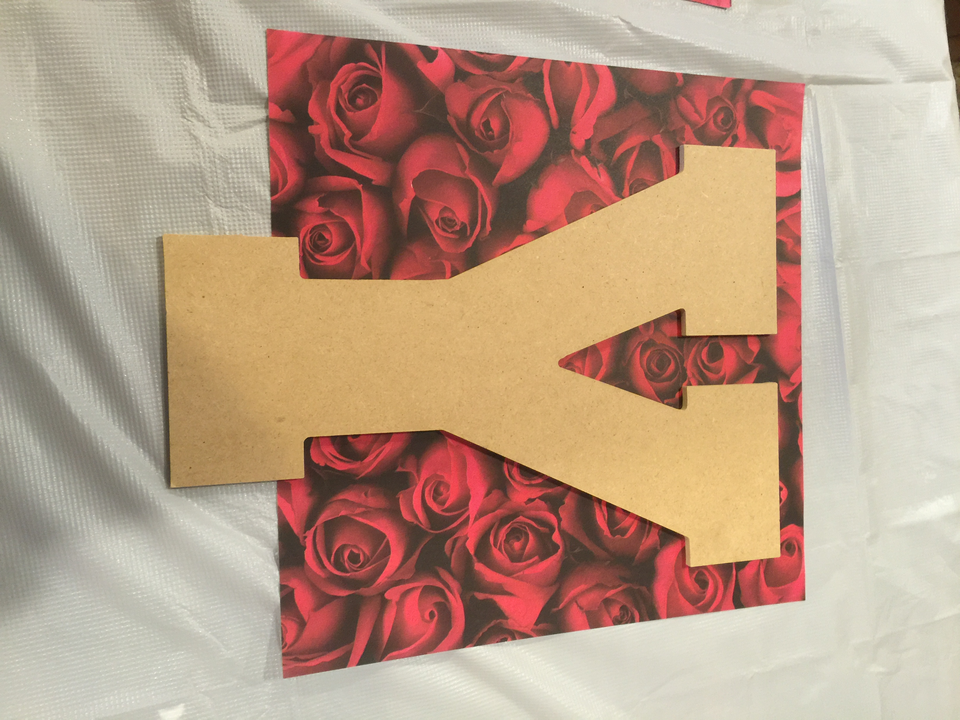

- Once I had purchased the supplies for the project, I placed the wood letter on a scrapbook paper page I chose, with the pattern facing up. I had to figure out how to position the “Y” in order to have the least amount of waste.

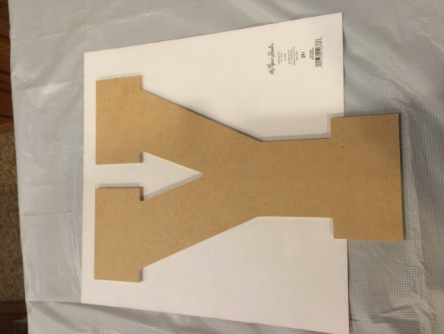
- After determining where to place the “Y”, I flipped the paper over so the pattern was facing down. I traced around the wood letter “Y” about ¼” larger than the actual wood. I did this so I was able to wrap the paper around the sides of the letter and onto the back.

- I cut the paper on the lines I drew around the wood letter “Y”.

- I placed the paper “Y” on top of the wood “Y” to ensure it was large enough. I then cut another piece of paper to cover the remaining portion of the bottom of the wood “Y”.

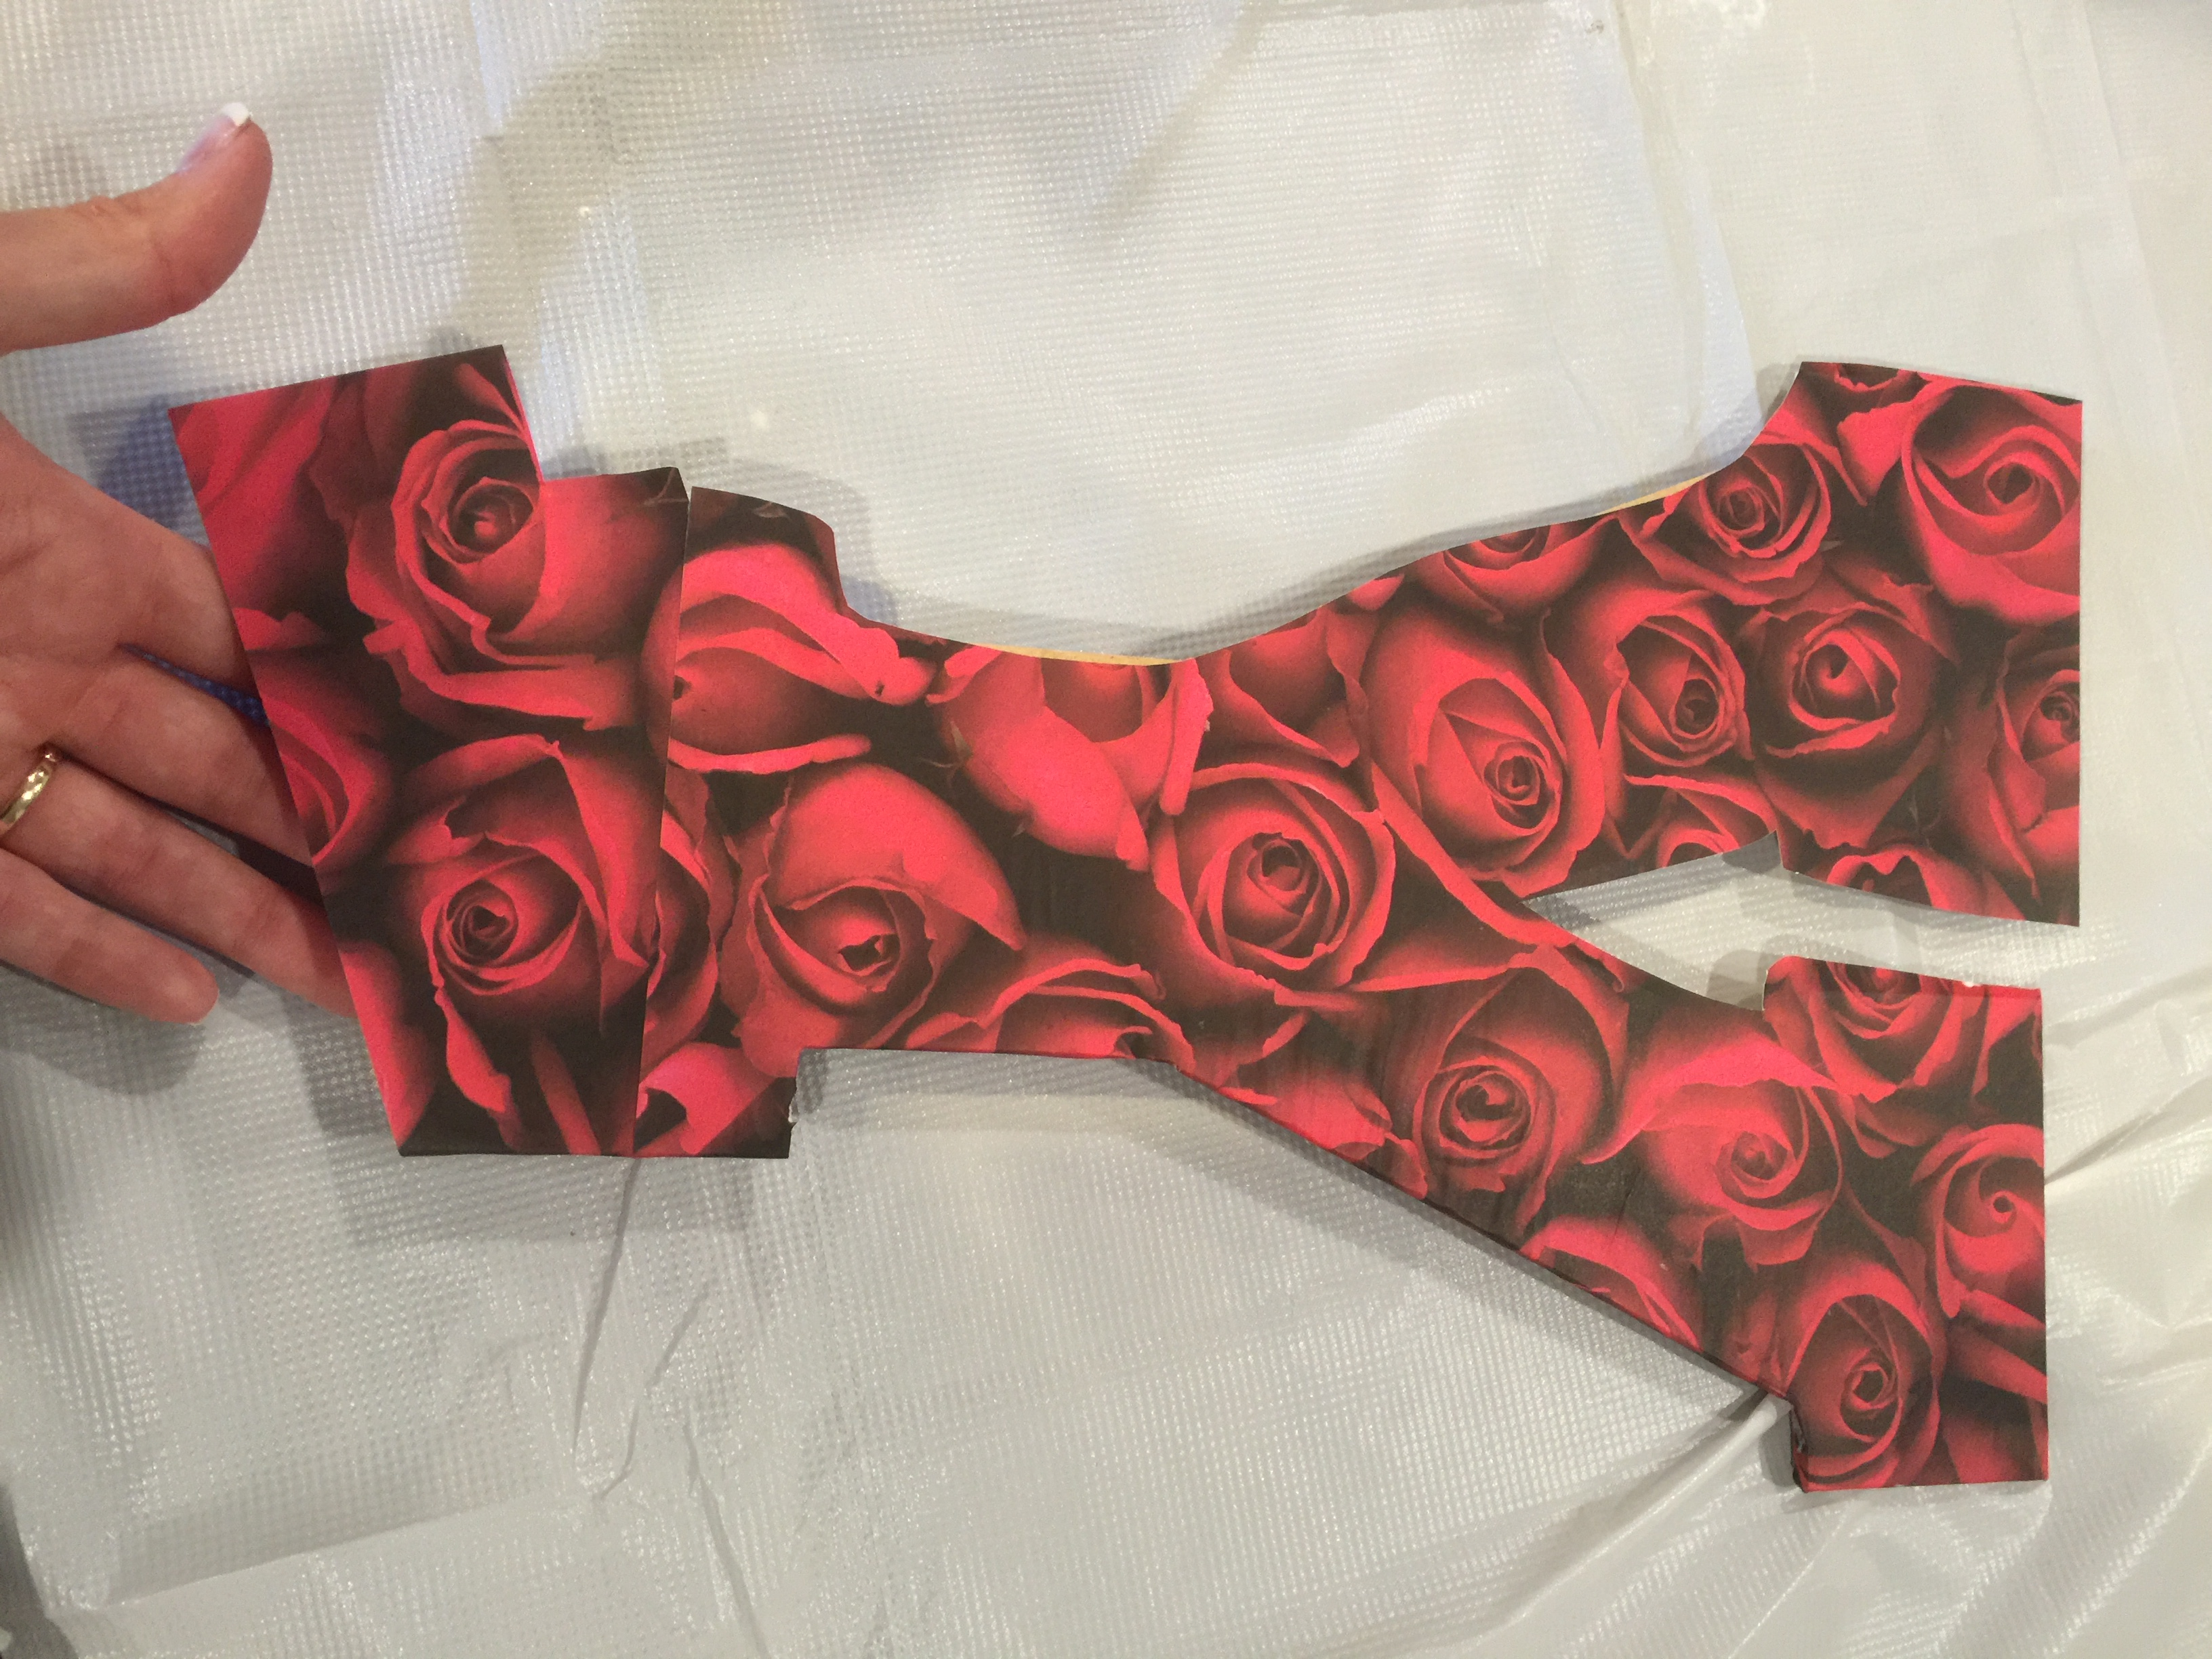

- I placed a thin layer of modge podge on the wood letter. I then placed the paper “Y” on top and began to smooth out any bubbles that may have appeared. After the large paper “Y” was in place, I placed the smaller paper piece on the bottom of the wood “Y”.

- I then let it dry for five minutes.

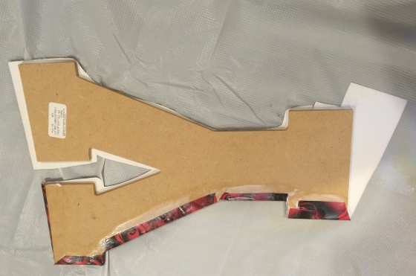
- I flipped the “Y” over so the paper side was facing down onto the table. I then began placing modge podge onto the excess paper and folded over onto the wood. I had to cut the paper when I hit a curve in the letter. I also didn’t cut the paper quite large enough so it was hard in certain spots. I then had to cut a piece of paper to cover the parts of the letter that were still showing wood.

- I painted a layer of modge podge onto the edges and back of the Y and let dry for 20 minutes.

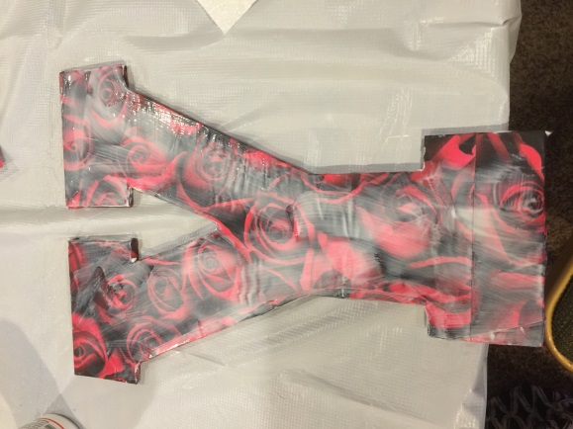
- After allowing the first layer on the sides and the back of the “Y” to dry, I flipped the project back over to the paper side facing up. I painted a thick layer of modge podge onto the entire letter making sure it was an even coat and let dry for 25 minutes.

- I then chose the embellishments I wanted to go with the paper. I knew I wanted to use the letter in my engagement pictures so I chose a ring set and Mr. & Mrs. Embellishments. I had to figure out the best place to place them on the “Y” and eventually chose a well-balanced placement.

- The next step was to paint a final layer of modge podge onto the entire “Y” and embellishments. I did not want a high-gloss finish, so I chose a matte finish modge podge.

- I then let dry for 25 minutes.

- After the modge podge was completely dry, I placed a deer antler ribbon on the edges of the “Y” to tie the project together.
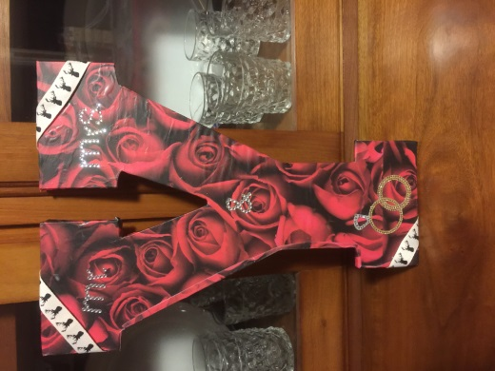

What Did I Learn?
- I learned that my free hand skills are not very good and I should have measured twice before I cut.
- I learned that I needed to have patience while allowing the coats of modge podge to dry.
- I learned that I could start and finish a project, for under $10, in about two hours.
- The hardest part of the project was waiting for the coats of modge podge to dry.

Elements & Principles of Design
- Color
  - Bright red is the main color with accent black areas
- Line
  - There are thick and thin lines throughout the project
  - The lines create the letter “Y” – my new last name initial
- Texture
  - The project is smooth and slick, except where there is bedazzled sections, then it is slightly rough
- Unity
  - The project has a whole goes well together – the different textures and lines bring the project together as a whole

