Ribbons and Awards Setup
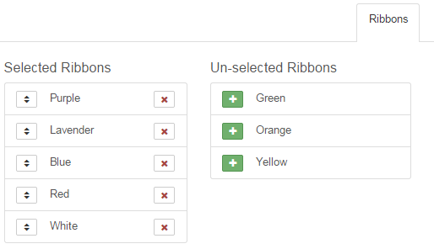
Ribbons
Setup >> Ribbons – Select all the ribbons available in your fair, and make sure they are listed in highest-to-lowest order. (Use the up/down arrow button on the left side of the ribbon name and drag to correct order.) This is how they will appear on the pull-down menu for on-screen entry of results. Ribbon choices are not selective—all ribbon colors appear as options for results on all entries.
Awards
Paper planning is your friend. Start with a list of all the awards that are given at your fair (Grand Champion Market Broiler, Photography Excellence Award, etc.) Once you have your awards listed, you need two pieces of information about each one, and that information will guide you through the rest of the setup process:
- Beside each award, note whether it is a class award or a division award:
- Class Award—an award that is given as the exhibit is judged in its class.
- Division Award—an award that is given as the exhibit is judged at the division level (this is most common in livestock—Grand Champion Market Beef would be given after the animal progresses from its class to show again at the division level).

- Beside each award, note where you would like to have results entry clerks see the award as an option for results. Balance the desire for a high level of specialization with the time required. You can create awards at the Fair level, or create them all for only the specific class in which they are available.
- “Grand Champion” could be used as an award at the Fair level, but you may wish to have it read “Grand Champion Market Beef” for your results export.
- Higher levels are quicker to set up, but will result in a long list of awards being available for each entry. Results entry clerks will see all options on results entry screens if they do on-screen entry.
- Lower levels (more specific) require more setup time, but less chance of the Photography award being given to a plate of cookies or a market beef animal. It also allows you to customize the exact name of the award without having a very long list of awards.
These are the options for determining where the award will be listed as an option on the results entry screen. Where you place them on the hierarchy is based on your balance of specialization and time.
- Fair—all entries in all departments will have the award listed as an option on the results screen
- Department—only/all entries in one department
- Division—only/all entries in one division
- Class—only/all entries in one class

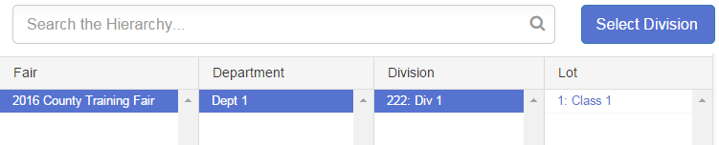
Once you have identified the 2 pieces of information for each award, begin entering the ones at the highest level identified in step 2. Go to the Hierarchy menu, and select the appropriate level.
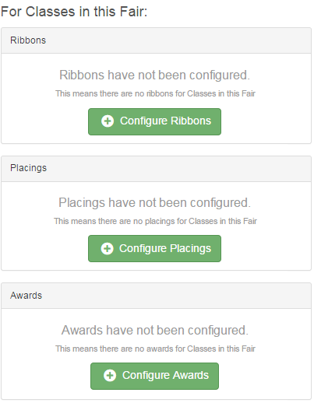
- Click on the Points & Premiums tab. It starts out with a screen as at right, “Ribbons (Placings, Awards) have not been configured”.
- Scroll down and you will see configuration options for both classes and divisions.
- Looking at the choice you made in step 1 above (Class Award or Division Award), click the “Configure Awards” button—either the top section “For Classes…” or the lower section “For Divisions…”
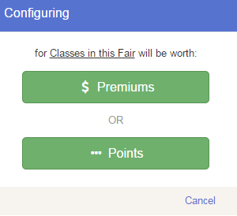
- If you are not attaching money to the awards, it does not matter whether you click Premiums or Points. The sample dialog box at right tells you that you are setting Class Awards that will be visible for the entire fair.
- Click Edit, and Add an Award to enter your awards. Delete if you add something in error. Save when complete.
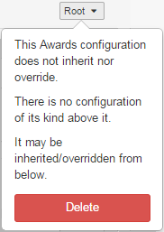
- Work through the list that you compiled in steps 1 & 2. As you go down from the top level to lower levels, you may find that you have to override a setup that was made higher. You will see a small pull-down menu at the upper right of the section name. It will say “Root”, “Inherited”, or “Overridden”.
  - Root – this is the level at which the information was entered, and it can be deleted. HOWEVER, that will delete the configuration at all levels below this as well. Selecting that requires a confirmation popup and will remove all of the setup for that section at the selected level of the hierarchy.
DO NOT use the Delete option if you just need to set an exception for (override) a premium setup at a lower level, or if you want to make a small adjustment—then use the Edit option at the lower right. Only use Delete when you want to start over.
  - Inherited – this award configuration was entered at a higher level, and applies to the level you are currently viewing (and all levels directly below this one). Choose “Override” to set an exception to the higher rule, while leaving that rule in place for all other levels of the hierarchy. Overriding awards replaces all awards at the higher level with the ones entered at the lower level, as opposed to adding to the original list.
  - Overridden – this award configuration has been overridden from the original root configuration. You can compare or reset to the root.

Placings
Even if you do not assign money for placings (1st, 2nd, etc.) this is where you have to set up which placings will be available to select in results.
You can choose to set up the largest number of placing values (1-10, etc.) at the FAIR level, with the result of the entire list showing up as options for all class entries; or selectively set up placing lists for departments etc. (1-10 for Horticulture, 1-5 for Swine, and 1-2 for Horses, for example).
- As with Awards, use the Hierarchy menu to select the correct level of the hierarchy.
- Click the “Configure Placings” button, and select either points or premiums (it doesn’t matter, if you’re not going to assign values).
- Click Edit.
- Click “Add a Placing” to have more than 1-2-3 available. Delete if you want fewer (only 1-2 for example). Save when complete.
Ribbons, Placings, Awards as Results
Each entry can have 3 pieces of results information recorded, at both the class level and the division level (if it is judged twice).
- Ribbons – these are assigned by the color of the ribbon, not by the text that may be written on it.
  - One ribbon color per entry per level—the highest ribbon color at each level should be the one recorded. For example, if a judge originally assigns blues & reds, and then goes back through the blues to pick out 2 purples, those 2 entries should have a “purple” ribbon recorded.
  - Ribbon colors can be assigned to multiple exhibits in the class—per the Danish evaluation model common at 4-H fairs: In a class of 25 exhibits, you can have “blue” assigned to 20 of them, etc.

- Placings – first, second, third, etc. compared to the other entries in the class or division
  - Only one placing can be assigned to each entry.
  - Each placing can only be used once within the specific class or division: Once 1st place has been assigned to one entry, it is no longer available to assign to other entries in that class.

- Awards – these are the special recognitions that are sometimes printed on the ribbons—Grand Champion, Best Junior Exhibit, Best of Breed, etc.
  - Multiple awards can be assigned to one entry. If a painting receives Best Use of Watercolor, Overall Creativity Award, and Best Junior Exhibit, all 3 of those can be assigned to the entry (at either the class or division level).
  - Awards can be assigned to more than one entry in a class. The Rate of Gain award could be assigned to any entry that has an ADG over 3.8, for example.

