Text Messages in 4hOnline (for now…)
By next season, there will undoubtedly be a Connect feature to allow you to send text messages similar to how you can send broadcast emails. But for now, you can use the data that exists in 4hOnline and send a group of text messages from Outlook.
Look in the Shared reports folder “Member List Formats”. There are two reports in there for you to use for text messaging: Text Addresses – All, and Text Addresses – Good. Right-click on the report you want, and choose Export to Excel from the drop-down menu.
- Text Addresses – All: List of all the members who filled out any PART of the 3 text message fields: permission checkbox, cell phone number, carrier. The addresses highlighted below are complete and good. The others are missing either the cell phone number or the carrier. There are additional information fields in this report so you can contact folks to get the missing information if you want.
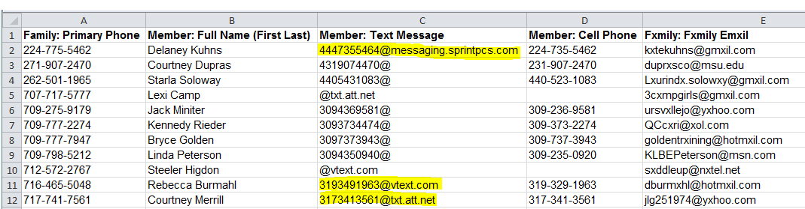
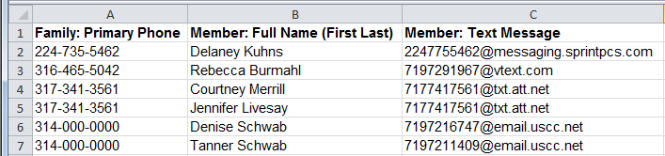
- Text Addresses – Good: List of the members who completed ALL 3 text message fields.

To send a text message:
- Highlight and COPY the addresses for the people you wish to contact.
  - If you are not highlighting a complete range, place your cursor in an empty cell on the spreadsheet, and PASTE. (If you don’t do this, you will end up with all addresses from the first one you highlighted to the last one you highlighted—including the non-highlighted ones.)
  - COPY the new shorter list from the spreadsheet.
- PASTE the addresses into the BCC field of a new Outlook email message.
- Type in your message.
  - You have 160 characters you can use, so be concise. If you exceed 160 characters, each person will receive multiple messages of 160 characters each. That will be bad.
  - Remove your email signature and any graphic elements you included in your signature or background, but do sign your name so that the recipient knows who sent the message.

