Using the Data tab
Reversing Youth to Adult role change
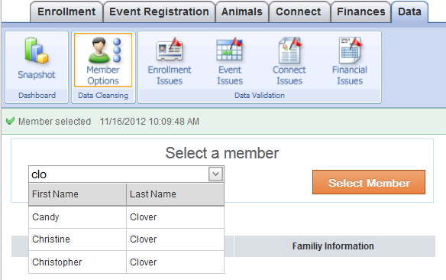
When a member reaches 18, the next time they re-enroll they are given the option to enroll as a youth or as an adult. Sometimes they become confused about the difference, and mistakenly enroll as an adult. You can change them back easily using the Data tab.
NOTE: The record must NOT be “active” in order for this to work…
- Don’t approve a member if you realize they’ve been changed into an adult record. Leave them pending.
- If you didn’t catch it until after they were approved, change them back to “pending” by using the DeActivate Member button at the bottom of their Profile screen before going any further.
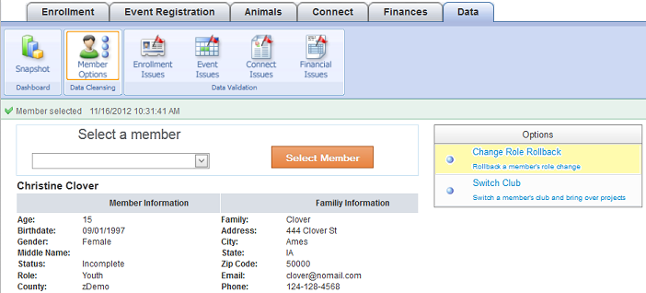
- Click on the Member Options icon on the dashboard.
- Begin entering the first letters of the person’s name (either first or last name).
- When the popup list of possible matching names shows up, click on the correct one.
- Click the orange Select Member button.
- Click on the top option “Change Role Rollback”. If it works as it should, there won’t be any further action needed. Double check by going back to the search screen or the family list screen.
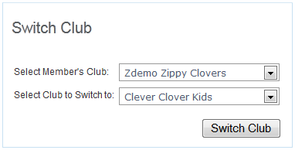
Changing a club membership, retaining project info
Follow steps 1-4 above.
- Click on the bottom option “Switch Club”.
- Enter the member’s original club, the new club, and click Switch Club.
- Wahlah. That’s “it”. The only way you know it was done is the blue info bar at the top of the screen:

